How to Create Policies in Compass
  - By John Oliver

Contents
Getting the Policies from ARC 3
Inserting the Policies into Compass 4
Files 6

Getting the Policies from ARC
- Leah (or another processor) sends an email with a list of policy numbers.
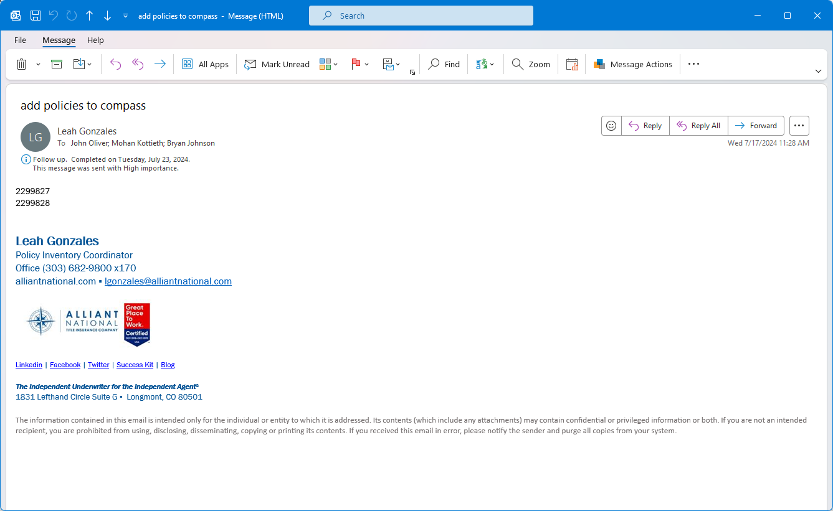
Figure 1: The email sent from Leah.
- Open SQL Server Management Studio and connect to antic-dev.database.windows.net.
- Copy and paste the contents of the SQL Script into a new query window.
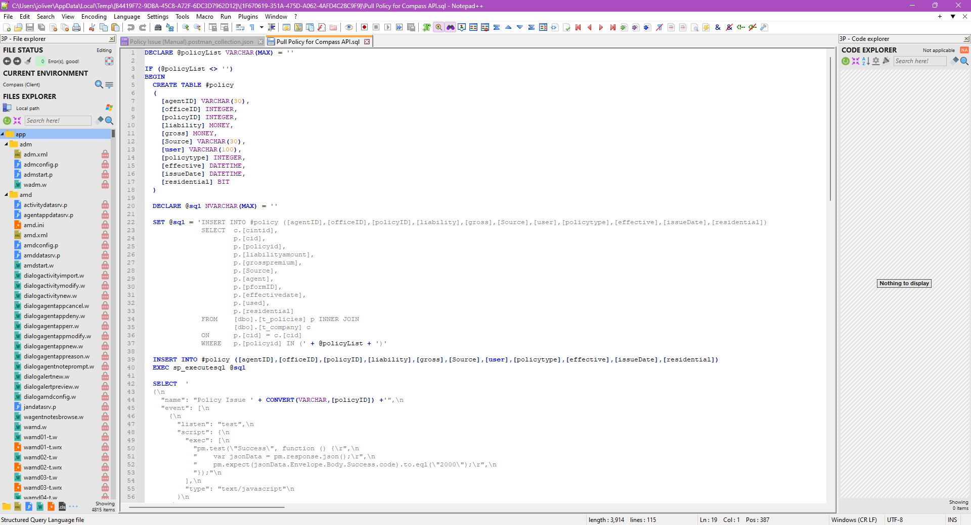  Figure 2: Copy the contents of the SQL Script… | 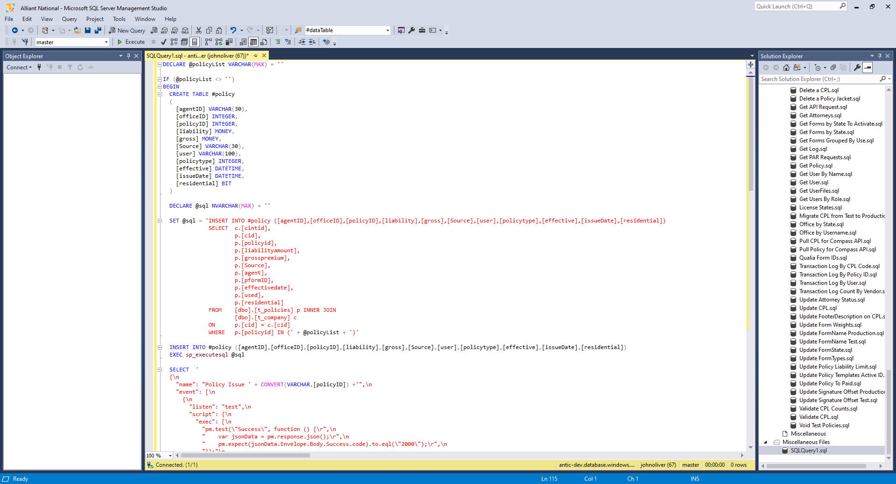  Figure 3: …into a new SQL Server query window.
- Copy and paste the policy numbers from the email and past them into the policyList variable.
  - Place a comma after policy number except for the last one.
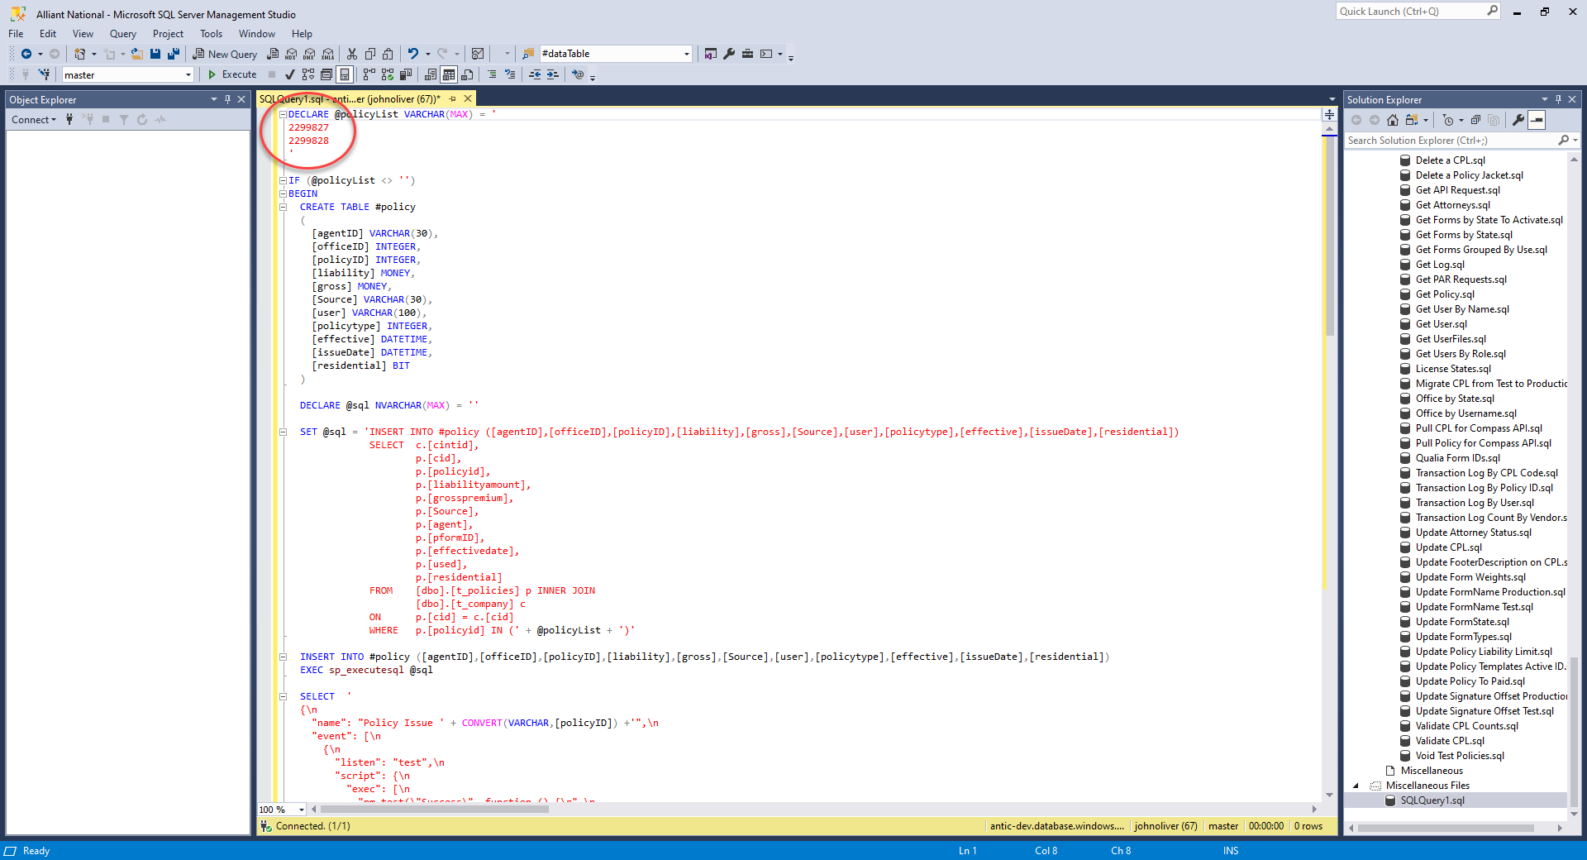  Figure 4: Copy and paste the policies into the variable. | 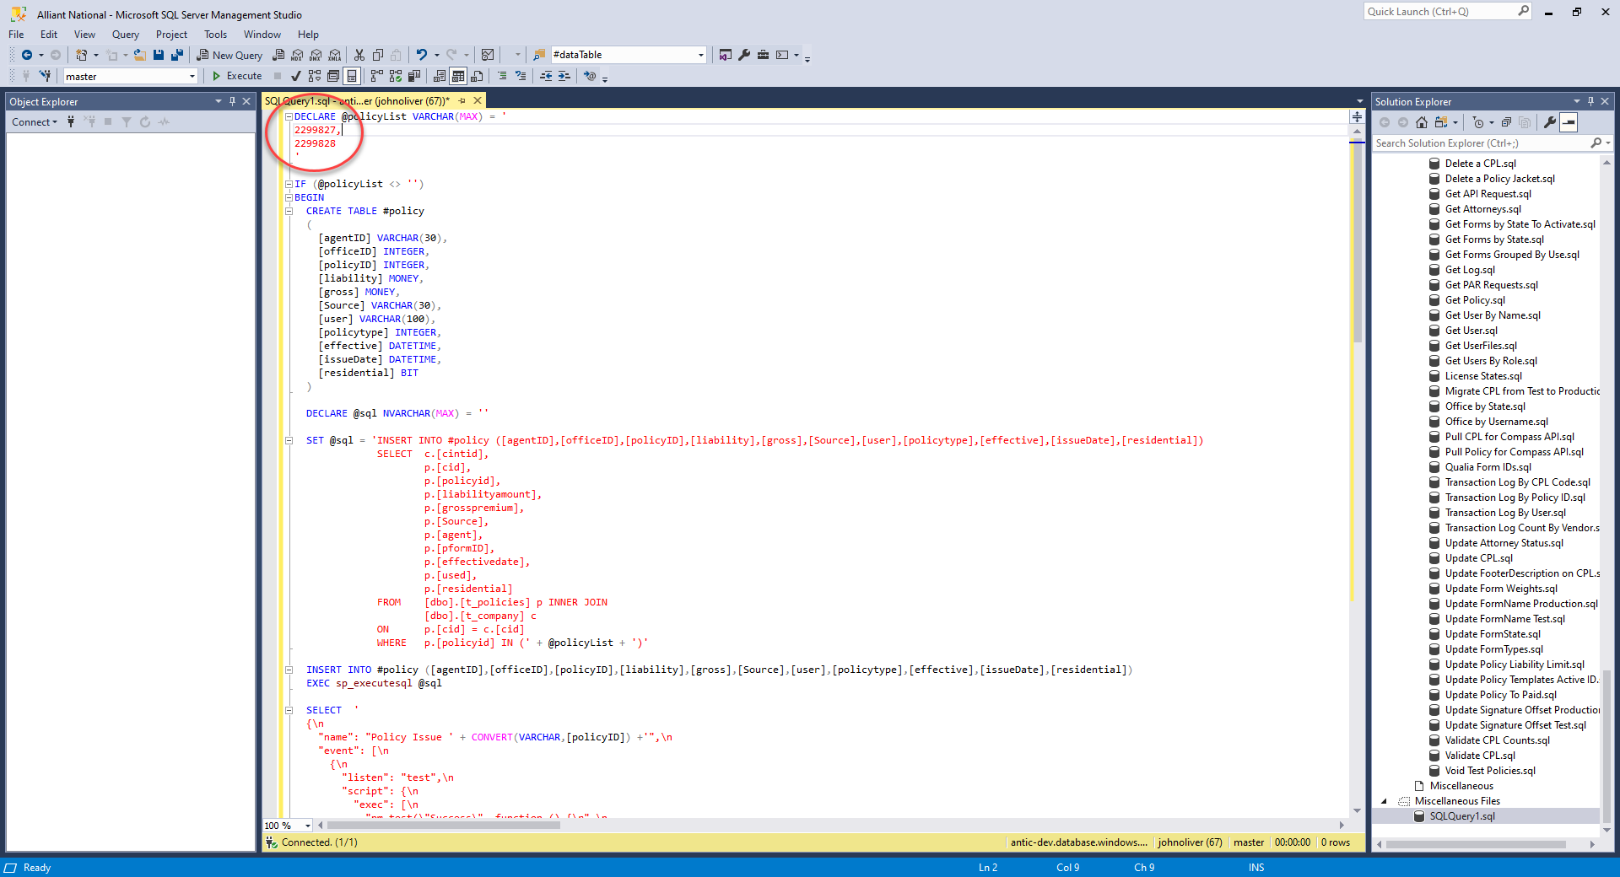  Figure 5: Place a comma after each policy number except the last one.
- Run the script against the antic_prod database.

Inserting the Policies into Compass
- Copy and paste the resulting rows into the Postman Collection document on line 8.
  - Hit Backspace on the keyboard to remove the last comma.
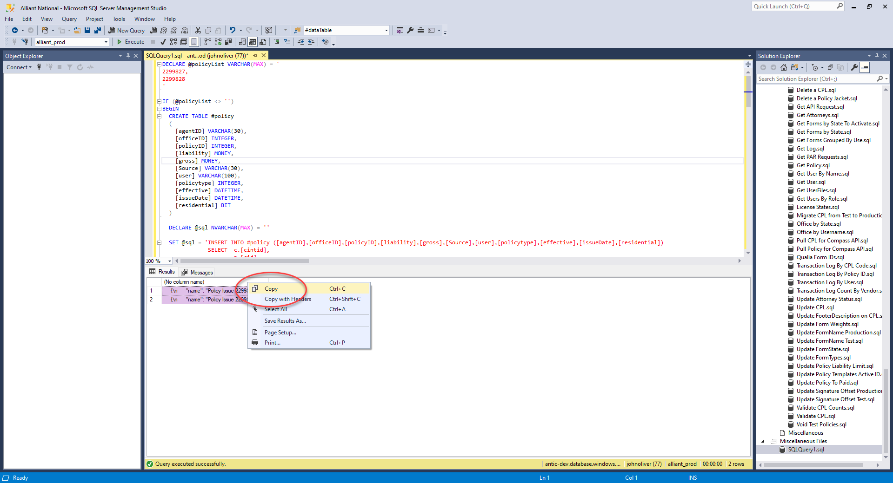  Figure 6: Copy the rows… | 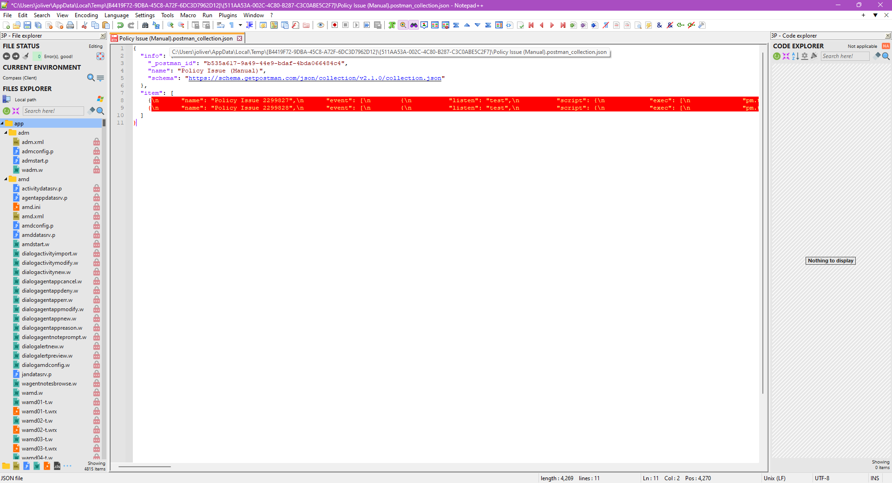  Figure 7: …and paste them into line 8.
- In the Replace dialog:
  - Set the Search Mode to Extended.
  - Type \\n in the Find what: field and \n in the Replace with: field.
  - Click the Replace All button.
- Save the document to the computer.
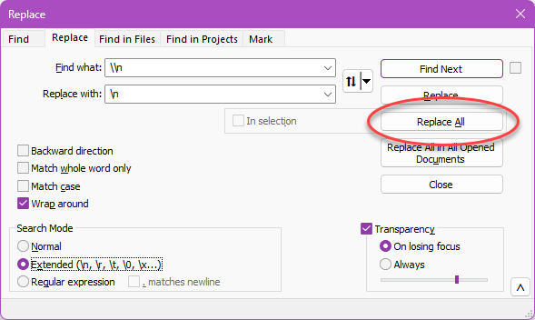  Figure 8: Replace the \\n with \n. | 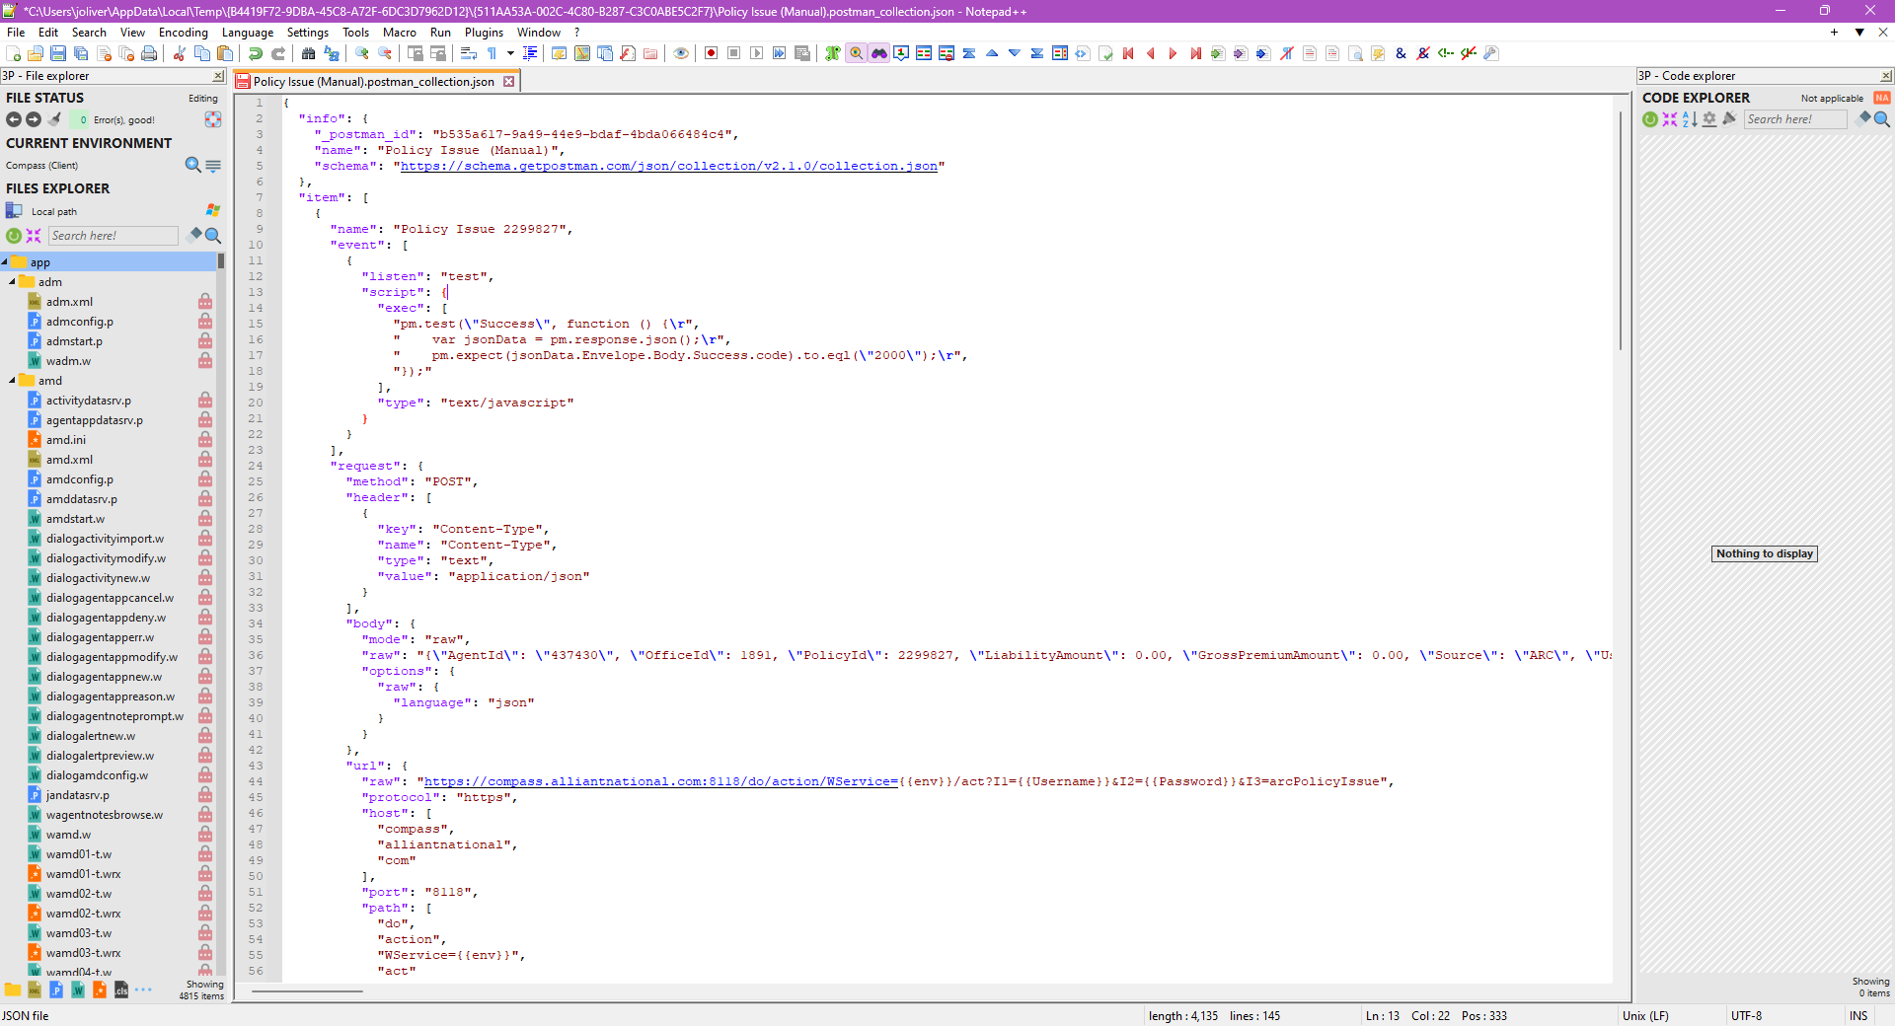  Figure 9: Save the result to the computer.
- Open Postman and import the saved collection from the previous step.
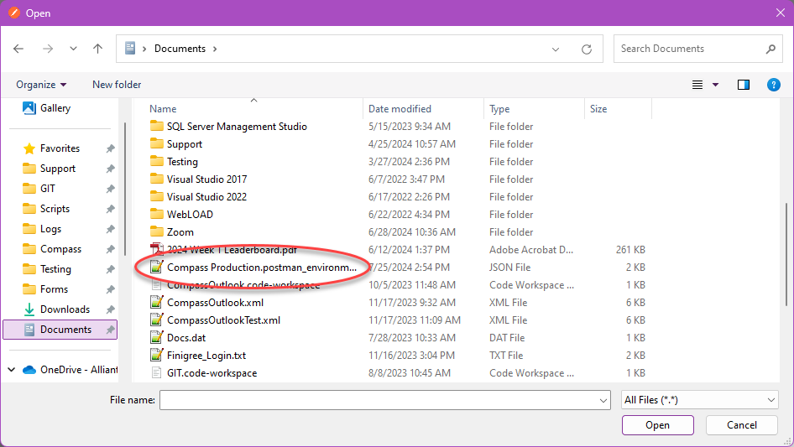  Figure 10: Import the collection. | 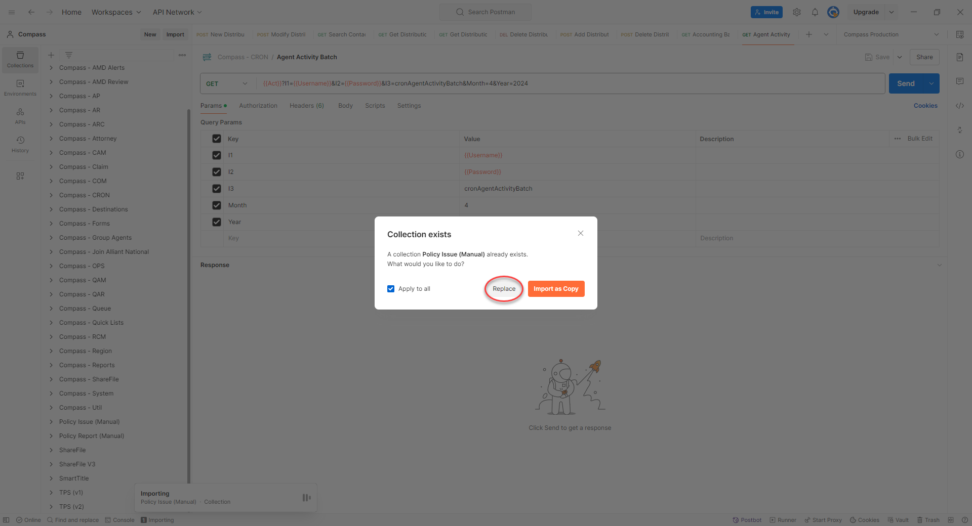  Figure 11: If already existing, click Replace.

- Set the environment to Compass Production, click the Run button, and click the Run Policy Issue (Manual) button.
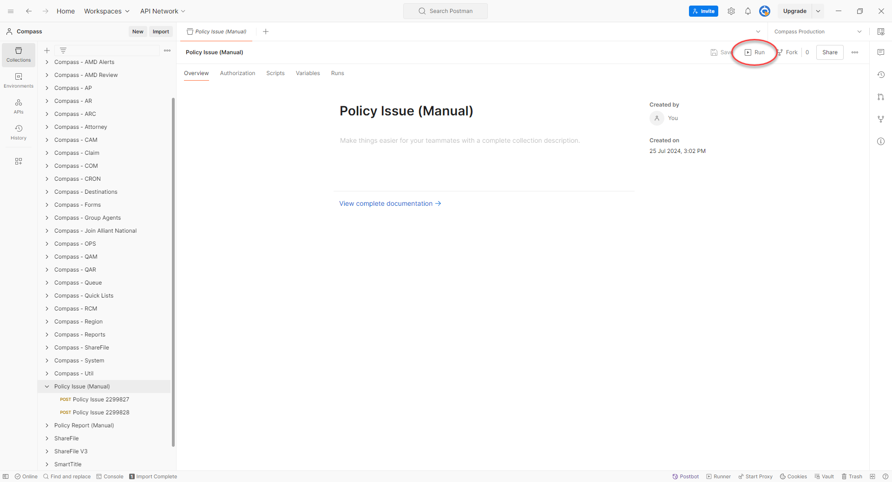  Figure 12: Click the Run button. | 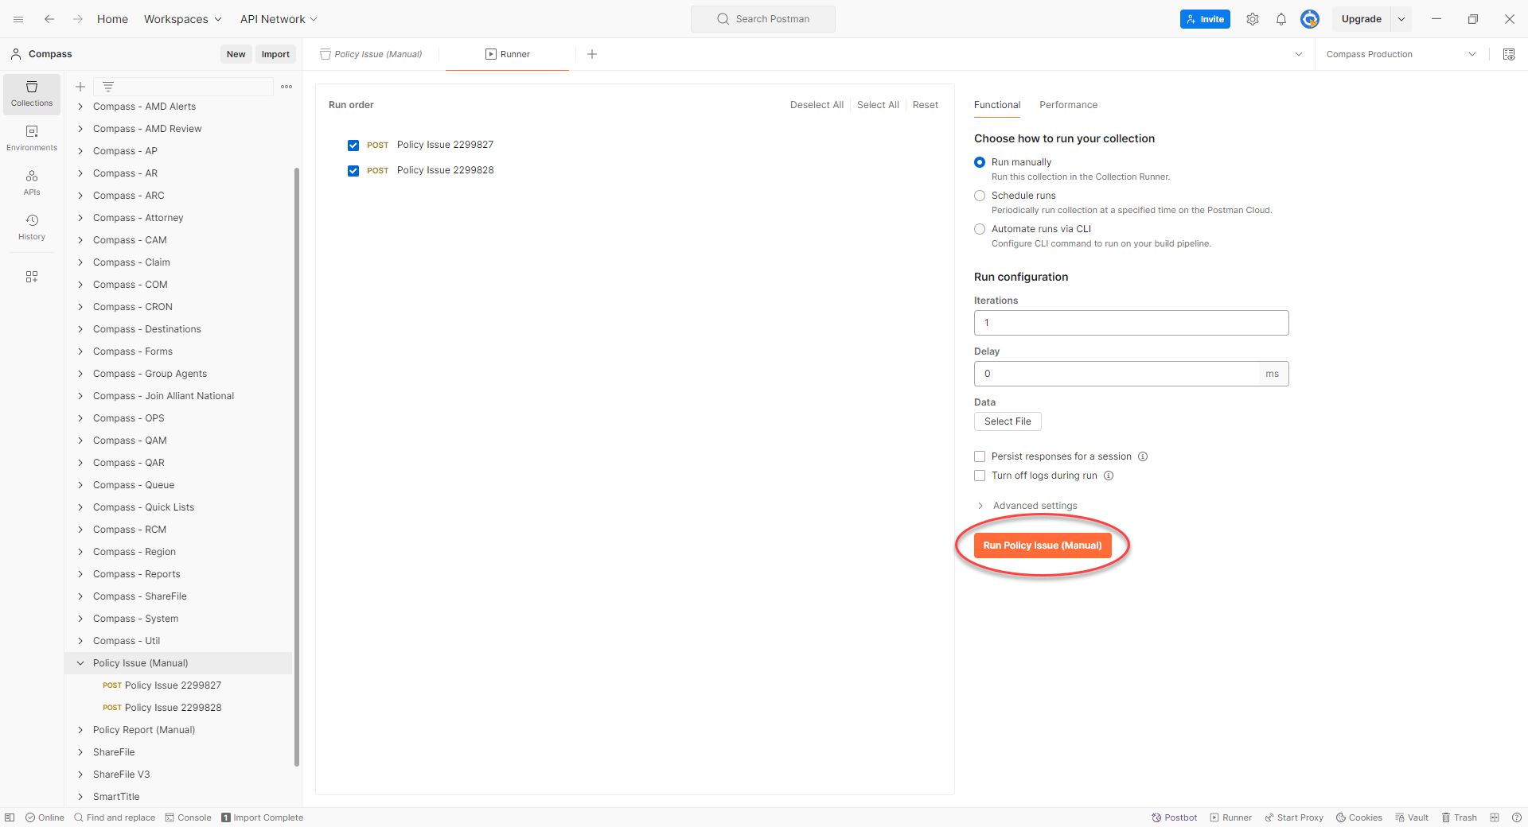  Figure 13: Click the Run Policy Issue (Manual) button.

Files
File | Description
 | SQL script used to pull policies from the ARC database.
 | JSON collection for running the policies via Postman.
 | Variables for Compass Production environment for Postman.
Table 1: Files needed to add policies to Compass.

